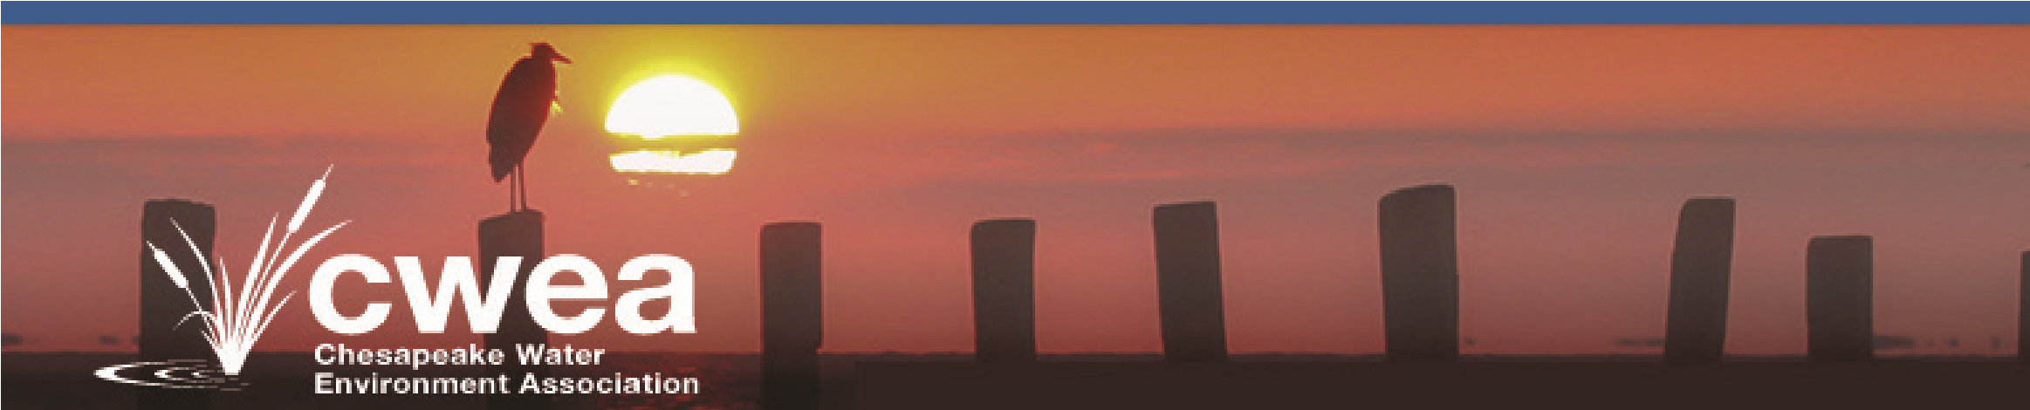
Member Association
Fast Fact sheet 2019
- Mission statement
The Chesapeake Water Environment Association (CWEA) is dedicated to improving water quality and protecting the water environment in Delaware, Maryland, and the District of Columbia. The Association strives to do this through public education, the exchange of technical and scientific information among water quality professionals, the training of wastewater and water treatment plant operators, and by offering technical expertise and advice to the law-making and regulatory processes.
- Membership
  - CWEA is a Member Association of the Water Environment Federation (WEF)
  - CWEA has approximately 850 members
  - CWEA includes Delaware, District of Columbia and Maryland
  - All CWEA members are also Water Environment Federation members
- Budget
  - Our annual budget exceeds $ 150,000.00
- Structure
  - 30 standing committees, including technical and business-related committees, and several joint committees with the Chesapeake Section of the American Water Works Association, Inc. (CSAWWA)
  - Leadership structure consists of a 12 officer Executive Board, which includes two (2) WEF Delegates
  - 501(c)(3) non-profit status granted in 2013
  - Joint CWEA/WWOA magazine, known as the “Ecoletter” published quarterly
  - Website: www.chesapeakewea.org
- Key Facts/Programs
    - Water Environment Federation (WEF) 2015 Member Association Achievement Award
    - Numerous technical seminars throughout the year, including
    - Collection Systems Committee Annual Seminar
    - Stormwater Committee Spring Seminar
    - Plant Operations & Maintenance Committee Seminar
    - Joint Water Reuse Committee Annual Seminar
    - Joint Spring Meeting with CSAWWA
    - Asset Management Committee Seminar
    - Monthly Webinar Series
    - Annual Ed Norton Open Golf Tournament - CWEA has partnered with the Federal Water Quality Association to award a scholarship to a local high school student from the proceeds
    - Annual Tri-Association Conference conducted jointly with WWOA and CSAWWA
    - Annual Short Course for Operators conducted jointly with WWOA and CSAWWA
    - Provide accredited training for operator certification and PDHs for Engineers
    - Hosted WEF 2014 Collection Systems Specialty Conference, Baltimore, MD, March 11-14, 2014
    - Hosted WEF 2015 Residuals and Biosolids Conference with Federal Water Quality Association (FWQA), Washington, DC, June 6-10, 2015
    - Support Baltimore City Water Industry Mentoring Program- YH2O. Partner with City of Baltimore, Mayor’s Office of Employment Development to provide mentors and training to this award-winning program.
For More Information on CWEA, Please Contact

Marlou Gregory, CWEA Executive Administrator marlou@chesapeakewea.org 410-960-5514
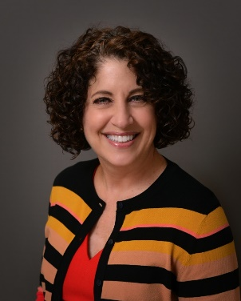
Ellen Frketic is Chief of the Water and Wastewater Engineering Division at the Maryland Environmental Service, where she focuses on providing support to the water and wastewater operations staff as well as planning and implementing capital improvements to the State of Maryland’s many treatment and conveyance facilities. As president of CWEA, Ellen is committed to expanding outreach to wastewater operators and is passionate about promoting reuse of wastewater effluent, gray water and stormwater. Ellen is a member of the 5S Society, AWWA, and the WateReuse Association and a former coach of MES’s Operations Challenge team, Motley Poo. She holds a bachelor’s degree in Civil and Environmental Engineering from Clarkson University.

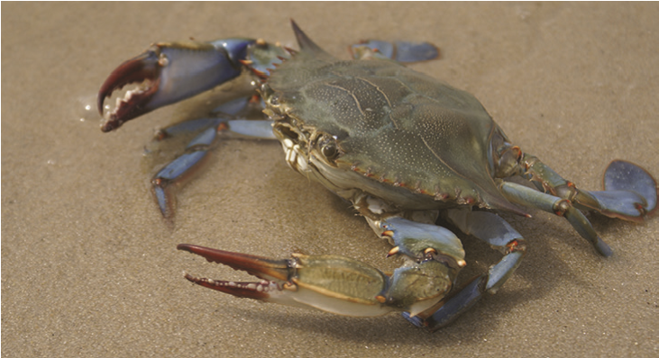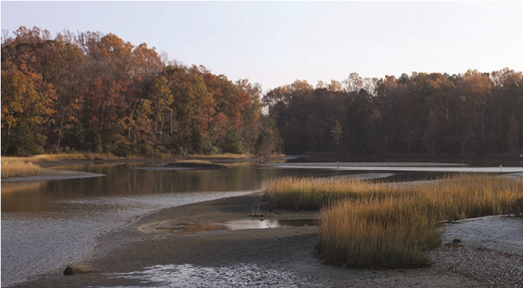
President
Ellen Frketic
MD Environmental Service
410- 729-8307

efrke@menv.com

President-Elect
Aaron Hughes

Washington Suburban Sanitary Commission
301-206-8776
410-729-8307
Aaron.Hughes@wsscwater.com

Vice President
Laura Jo Oakes

EA Engineering, Science & Technology
410-584-7000

loakes@eaest.com

Past-President
Jennifer Kaberline
Hazen and Sawyer
703-537-7915

jmoore@hazenandsawyer.com

Trustee-DC
Gian Cossa
DC Water
202-787-2708
gian.cossa@dcwater.com

Trustee- DE
Prabhu Chandrasekeran
Greeley and Hansen
301-552-6113
pchandrasekeran@greeley-hansen.com

Trustee-MD
Clarence Beverhoudt
Washington Suburban Sanitary Commission

301-2067575
clarence.beverhoudt@wssc.com

Utility Member Representative
Scott Harmon

Retired
410-777-3050
Scottharmon2@gmail.com

Secretary
Alan Will
JMT
301-908-8096
awill@jmt.com

Treasurer
Cece Nguyen
Brown and Caldwell
301-479-1250
cnguyen@brwncald.com

WEF Delegate
James Shelton
Arcadis
302-723-1450
james.shelton@arcadis-us.com

WEF Delegate
Tim Wolfe
KCI Technologies
410-316-7849
timothy.wolfe@kci.com

www.chesapeakewea.org

